
CSA05-DATABASE MANAGEMENT SYSTEMS

AIM
To perform subquery and correlated query on the given relations.

DESCRIPTION
A subquery is a query written inside another query. The inner query provides a value or set of values used by the outer query. A correlated subquery refers to a column from the outer query and is evaluated in relation to each row processed by the outer query.

TABLE USED
CoffeeShop

1. Select Database
USE collegedb;
OUTPUT:
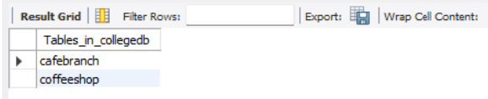
____________________________________________________________

2. Find Coffees Priced Above the Average Price
SELECT CoffeeName, Price
FROM CoffeeShop
WHERE Price > (
SELECT AVG(Price)
FROM CoffeeShop
);
OUTPUT:
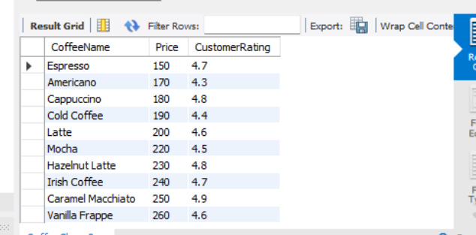
____________________________________________________________

3. Find the Most Expensive Coffee
SELECT CoffeeName, Price
FROM CoffeeShop
WHERE Price = (
SELECT MAX(Price)
FROM CoffeeShop
);
OUTPUT:

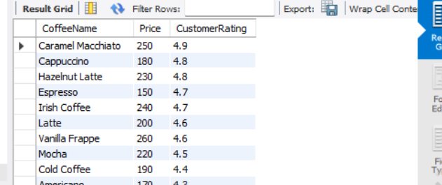

4. Find Coffees Introduced in the Earliest Year
SELECT CoffeeName, YearIntroduced
FROM CoffeeShop
WHERE YearIntroduced = (
SELECT MIN(YearIntroduced)
FROM CoffeeShop
);
OUTPUT:
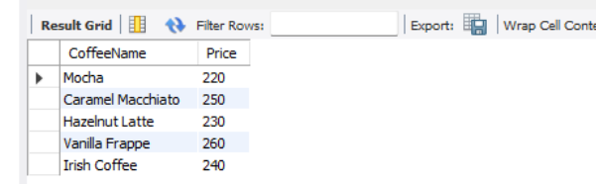

5. Find Coffees Whose Price Is Above the Average Price of Their Own Size
SELECT
c1.CoffeeName,
c1.Size,
c1.Price
FROM CoffeeShop c1
WHERE c1.Price > (
SELECT AVG(c2.Price)
FROM CoffeeShop c2
WHERE c2.Size = c1.Size
);
OUTPUT:
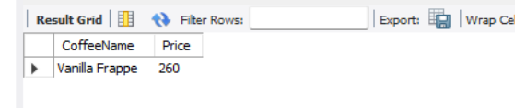

6. Find Coffees Having a Higher-Priced Coffee of the Same Size
SELECT
c1.CoffeeName,
c1.Size,
c1.Price
FROM CoffeeShop c1
WHERE EXISTS (
SELECT 1
FROM CoffeeShop c2
WHERE c2.Size = c1.Size
AND c2.Price > c1.Price
);
OUTPUT:
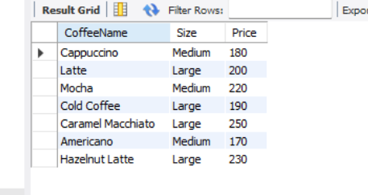

RESULT
Thus, subqueries and correlated subqueries were successfully executed using the CoffeeShop table.

